**Robotics – Assignment 2**

The environment displayed is a 33 by 33 square grid. The blue node represents the start node and the green node represents the goal node. The red color represents the nodes and edges traversed in order to get from the start node to the goal node. The gray nodes represent obstacles.

**Environment 1**

**Bug 1**

**Pair 1**: Start index: (0,0) Goal Index: (32,32)

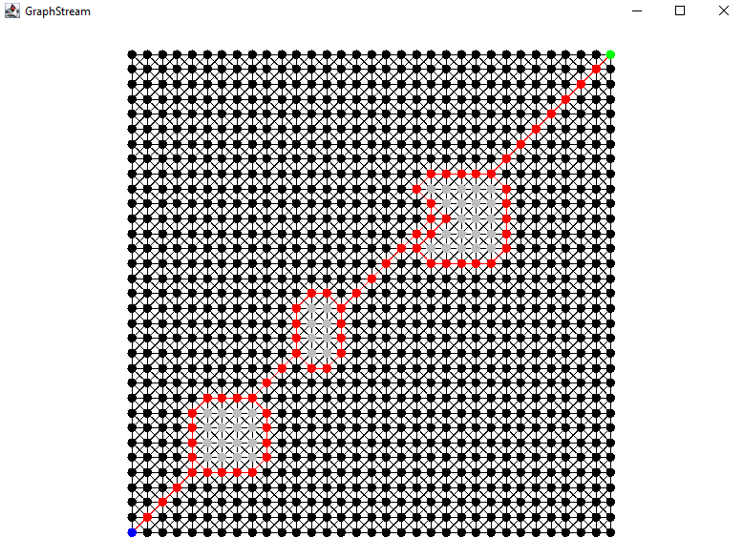

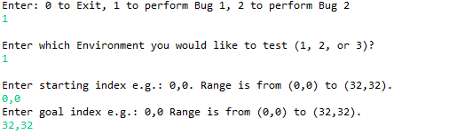

**Pair 2**: Start index: (2,5) Goal Index: (24,30)

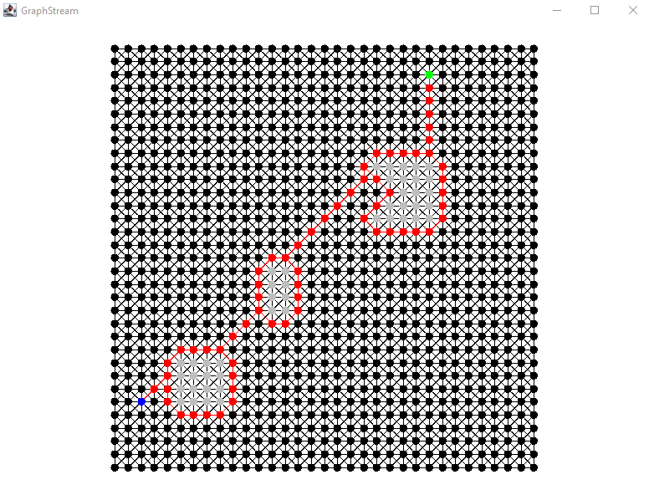

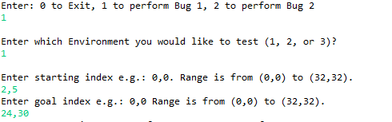

**Bug 2**

**Pair 1**: Start index: (0,0) Goal Index: (32,32)

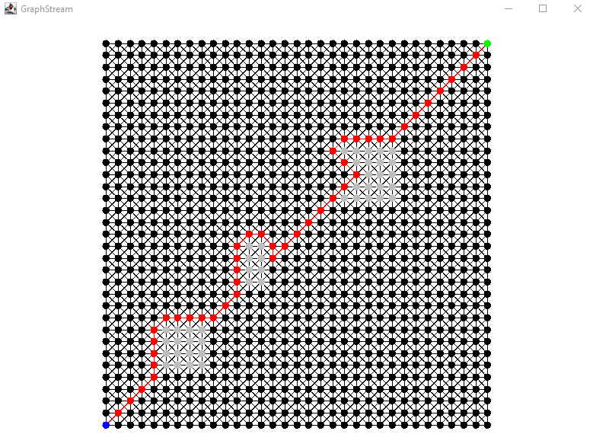

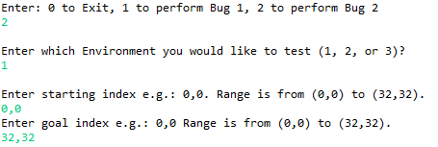

**Pair 2**: Start index: (2,5) Goal Index: (24,30)

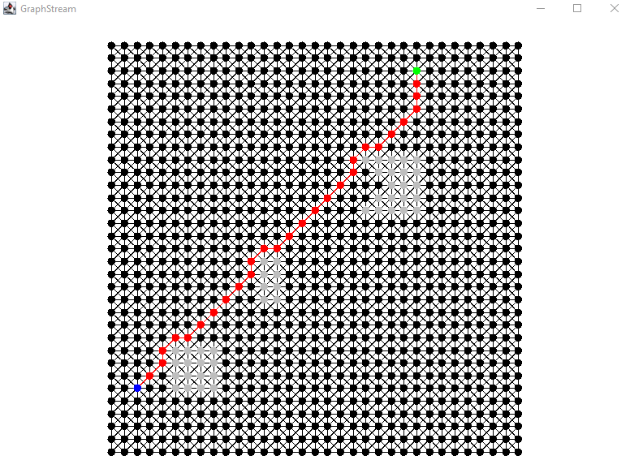

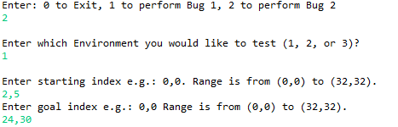

**Environment 2**

**Bug 1**

**Pair 1**: Start index: (0,32) Goal Index: (32,0)

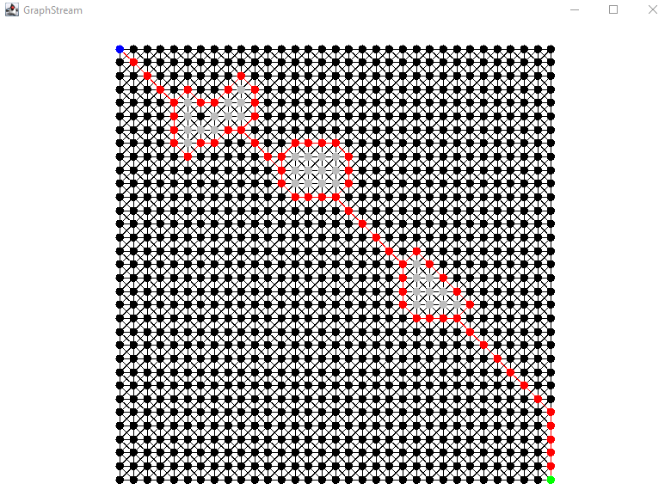

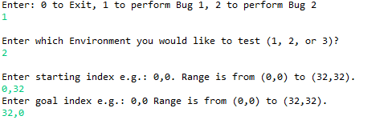

**Pair 2**: Start index: (25,11) Goal Index: (6,29)

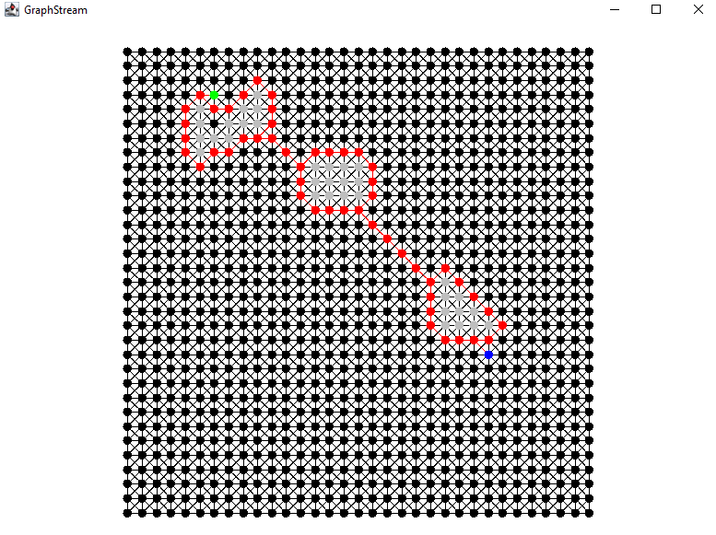

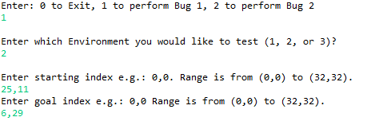

**Bug 2**

**Pair 1**: Start index: (0,32) Goal Index: (32,0)

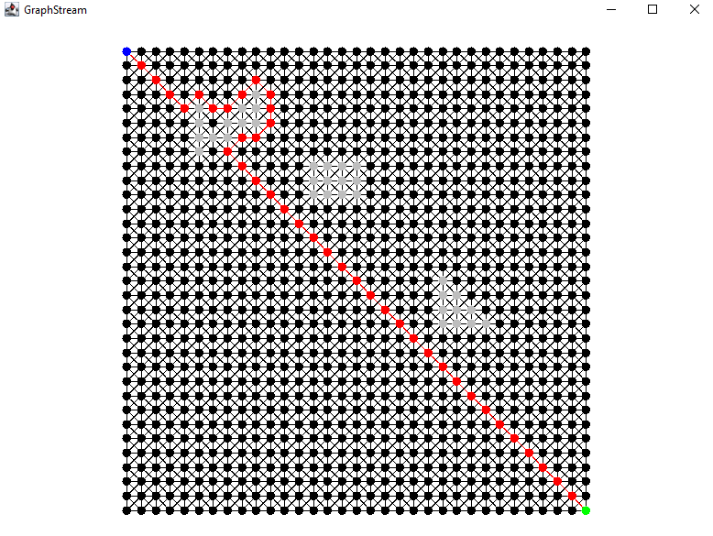

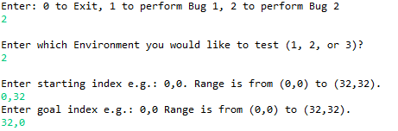

**Pair 2**: Start index: (25,11) Goal Index: (6,29)

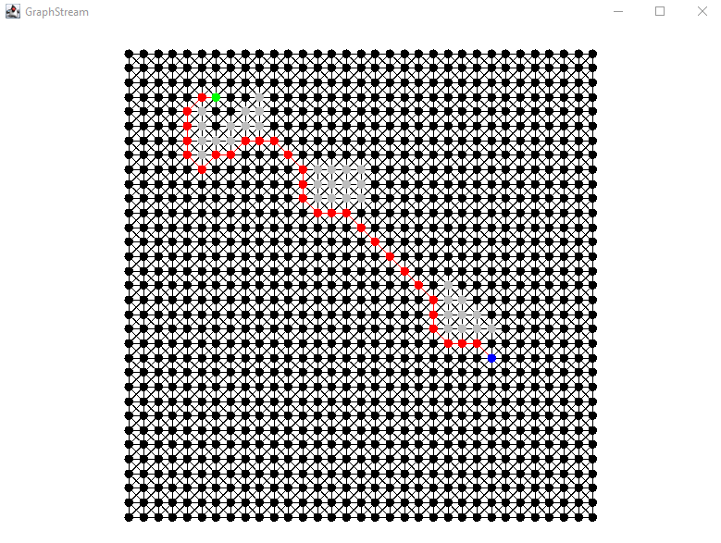

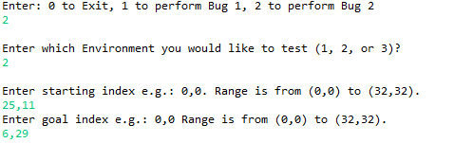

**Environment 3**

**Bug 1**

**Pair 1**: Start index: (2,15) Goal Index: (30,15)

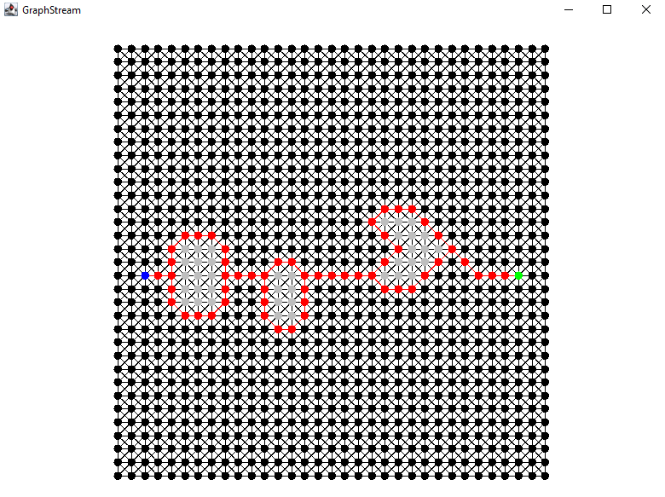

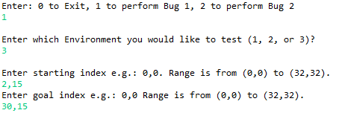

**Pair 2**: Start index: (26,20) Goal Index: (3,14)

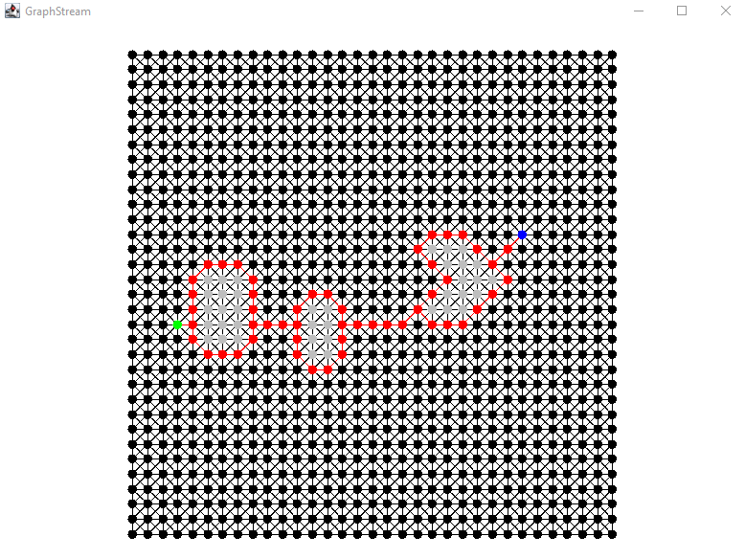

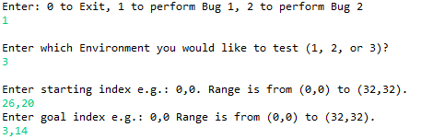

**Bug 2**

**Pair 1**: Start index: (2,15) Goal Index: (30,15)

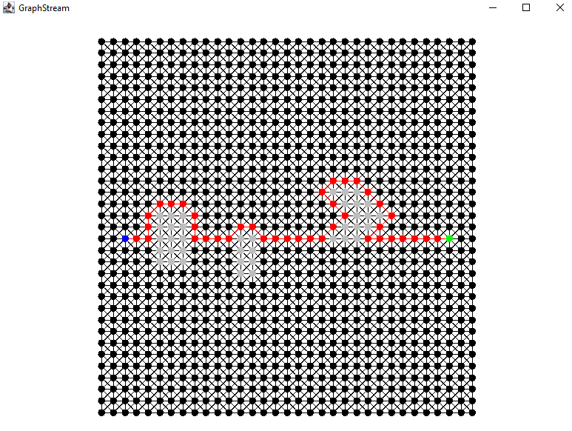

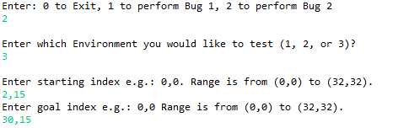

**Pair 2**: Start index: (26,20) Goal Index: (3,14)

